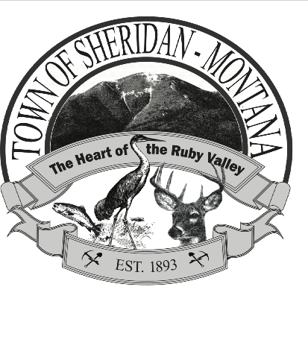

SPECIAL TOWN COUNCIL MEETING
TOWN HALL 103 E HAMILTON
August 29, 2024, 6 PM

Call to Order
Pledge

Public Comment Not on the Agenda
Public Comment On the Agenda

Minutes for July 8 and 17, 2024, August 12, and 15, 2024

Unfinished Business:
Tom Roberts Livestock Well: Discussion/action
Rural Fire Interlocal/Agreement Contract Discussion/action
Zoning Board: Additional Committee Members Discussion/action

New Business:
Curtis Voting Other than Public Works Discussion/action
Personal Policy Manual Revision: One Year
Probationary Period Discussion/action
Financial:
- Banking: Check Signees Add/Remove
and Administrator Discussion/action
- Credit Cards for Town Employees and Mayor also
Removal of Debit Card Discussion/action
- Removal of Petty Cash Discussion/action
- Cell Phones for Town Employees and Mayor Discussion/action

Adjourn

