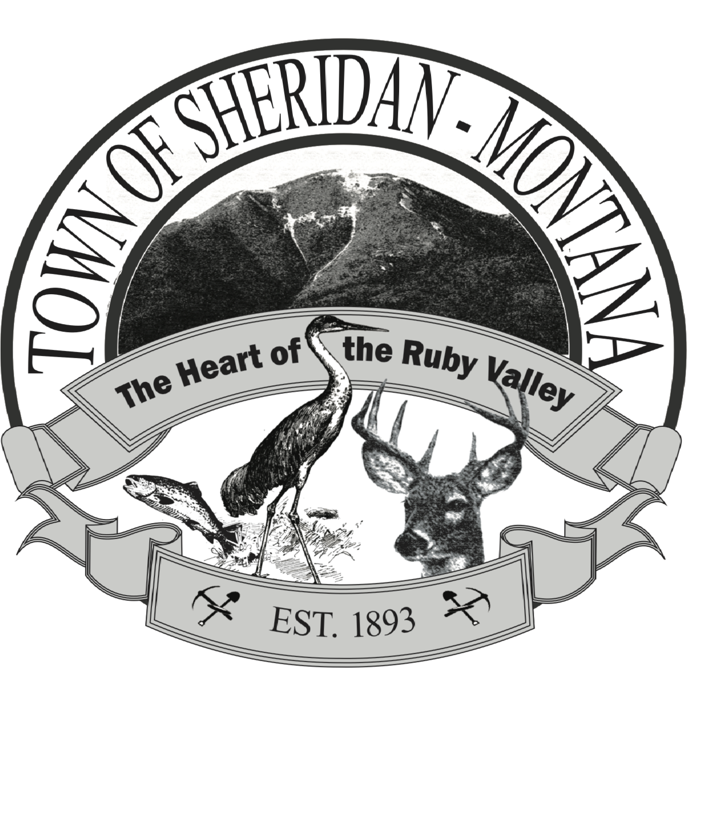

REGULAR TOWN COUNCIL MEETING
103 E. Hamilton St.
Sheridan, MT 59749
Monday November 13, 2023 6PM

Call to Order
Pledge
Public Comment for items not on the agenda

Approval of minutes from Sept 11, Sept 25, October 9,

Department Reports
Sheriff
Library
Attorney
Fire Department
Public Works
Finance
Mayor
Town Council

Boards and Committees
MSIT
Park District Board
SCCF

New Business
Public Records Request Discussion/ action
Triple Tree Engineering work orders Discussion/action
-Zoning
-Water line replacement
Existing Ordinances Review
Policy Development Discussion
Selection of Council President

Adjourn

