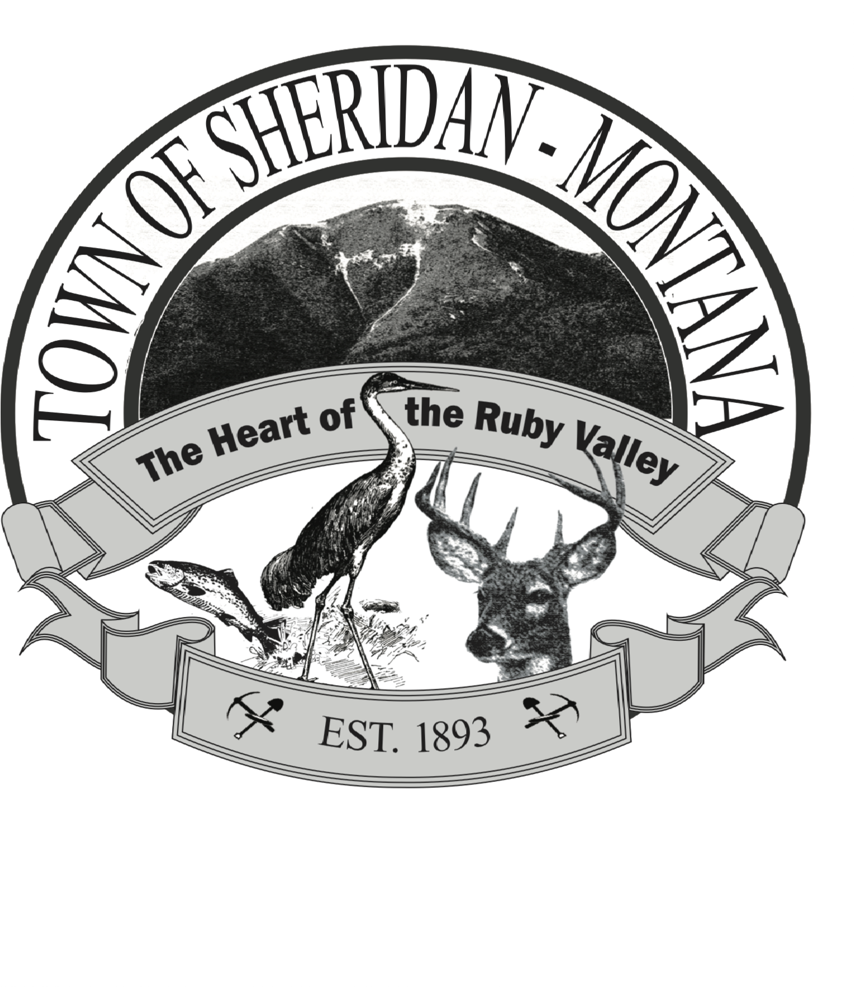
TOWN COUNCIL MEETING
103 E Hamilton, Sheridan, MT 59749
Wednesday September 13, 2023 6PM

Call to Order
Pledge
Public Comment

Approval of Minutes from 8-14-23

Department Reports
Sheriff
Library
Attorney
Fire Department
Public Works
Finance
Mayor
Town Council

Boards and Committees
MSIT
Park District Board
SCCF

Old Business
Redundant well project Discussion/Action
Engineering RFQ Score review and selection Discussion/Action
Interim zoning resolution 1st reading

New Business
Ruby Valley Hospital
Election Resolution – Action

Adjourn

