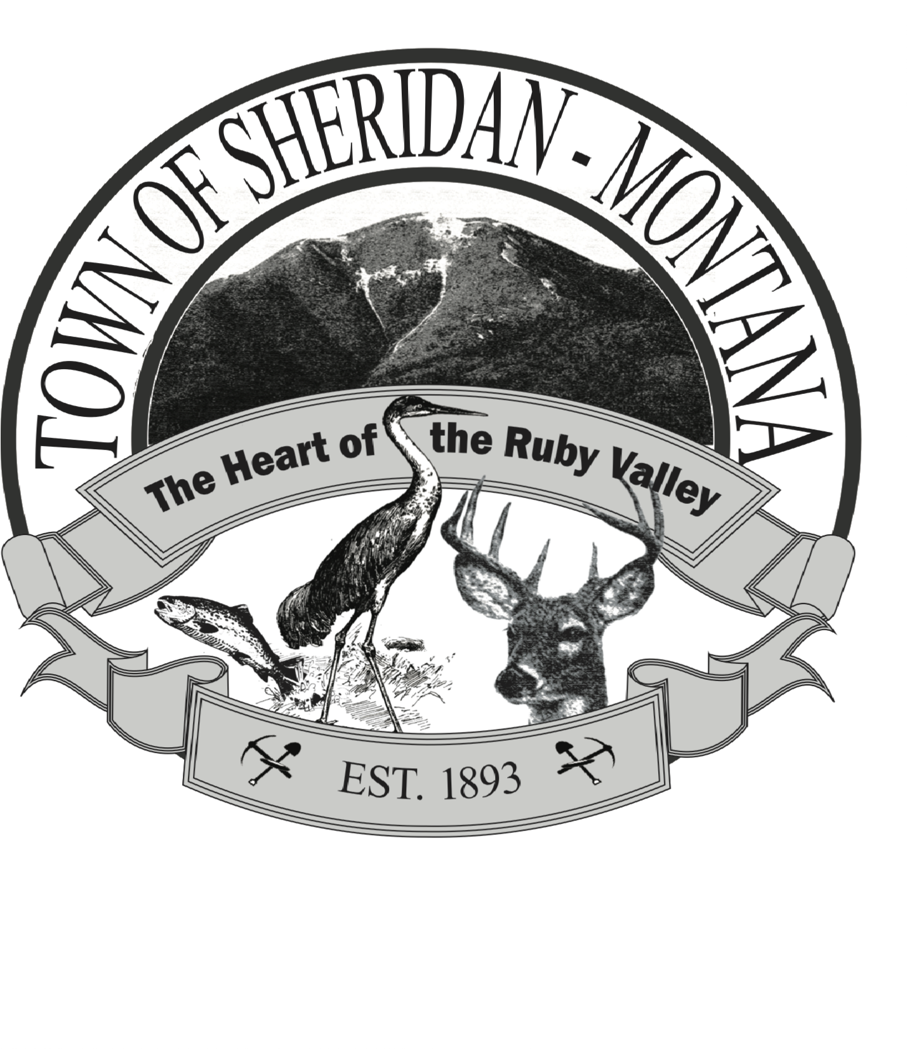

NOTES FROM THE MAYOR

Winter greeting from Town Hall! It doesn’t feel or look like winter in Sheridan, but we all know that can change quickly.

Someone recently asked me what my agenda was as mayor. I tend not to like the word agenda as it has evolved into meaning a hidden plan, so I decided to address what I think are my principles and initiatives. The “Edwards Administration” has 4 driving principles: transparency, public safety, and lawful administration of responsibilities and sound fiscal management. Every action and decision is run through these principles as we determine our way forward; are we working in full view of the public, does it advance public safety, are we performing according to the laws of Montana, and are we financially sound.

Initiatives are focused on areas that will improve quality of life for Sheridan citizens, such as improved streets, waterline integrity, recreational opportunities for youth, a dog park, walking paths, maintaining the history and culture of our area. I welcome and encourage everyone to provide ideas and suggestions for our town. I would also like to update our records, policies, and procedures so we are more effective and efficient as a town government.

The first reading of the modifications to the Growth Policy Plan will be at the next Town Council meeting on December 11, 6PM, at the Senior Center. The modifications allow us to start the zoning process but do not implement any zoning at this time. The County Planning Board has recommended Sheridan adopt the changes.

There is a new funding opportunity for town infrastructure coming up. This allows improvements to water, sewer, wastewater, or town buildings. We will be asking for recommendations at the next meeting so if you have a project you think should be submitted, please speak up at the next Council meeting or stop by Town Hall. We will submit a list of priorities to the state at the end of December and then follow up with which ones best meet the criteria.

As we move into the Christmas Season, I wish all of you a joyful, healthy, and safe Holiday. We are so very lucky to live where we do with the beauty of nature around us and good friends beside us.

Merry Christmas and Happy Holidays from all of us at Town Hall: Jennifer, Ty, Zach, Bill, and Judy!

