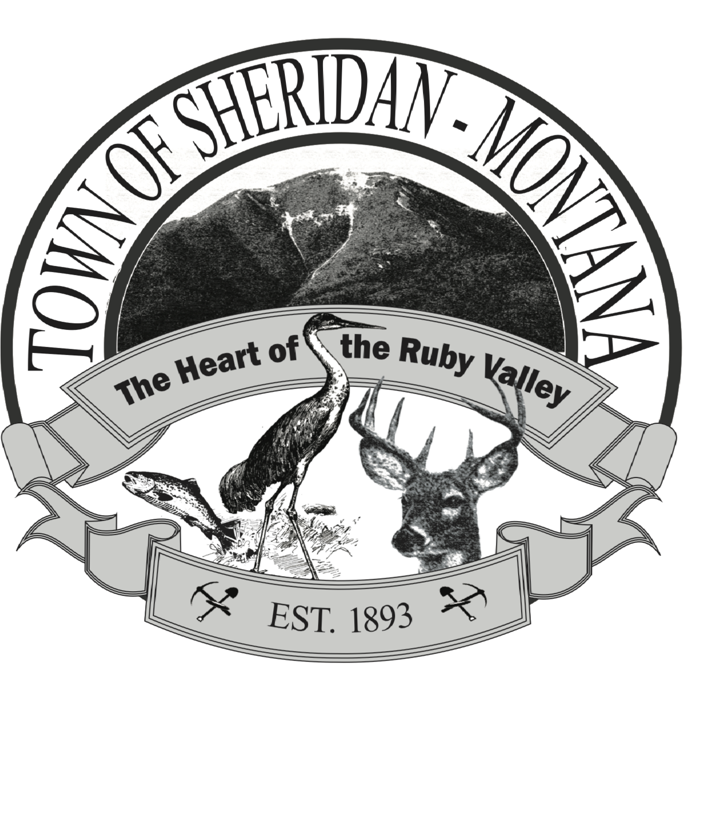

NOTES FROM THE MAYOR
OCTOBER

October is here!! For the Irish, the old ways say Halloween is the start of the New Year and is celebrated by putting out the old fires and gathering to start fresh. I love that idea!

A core tenet of my public service is the public right to know. I don’t know if you or your family were in Montana during the days of the Copper Kings. Mine was and I grew up on stories of Clark and Daly and the corruption that came from those years. I apologize for messing up on the public notice of the renewal of the Interim Zoning Ordinance. I thought that since it was an extension of an existing ordinance the 15-day notice in the paper wasn’t required. My mistake! It wasn’t an intentional effort to slip something by the community. The learning continues!!

The next Interim Zoning Ordinance special hearing and public comment will be October 9 at the Senior Citizens’ Center at 6 pm followed by our usual monthly meeting.

Please do not put anything that is not toilet paper down the sewer including “flushables” because our system lift station pumps can’t handle them. Other waste water systems have banned “flushables” for the same reason. This includes baby wipes, do-wipes, and other personal hygiene products.

In an effort to make the Town Hall feel more inviting, we would like to invite local artists to display their work at the Town Hall. Depending on the interest, we would rotate the art every two months or so. Work can be marked for sale. Please stop by and let us know of your interest and the size of your works for display. We have some serious talent in our community and it’s time to showcase it.

Sheridan has an ordinance for late fees on water/sewer bills. Starting with the October 25th reading, a $5 late fee will be assessed. Check your bill for due dates. If you feel there is an error in your bill, please stop by and discuss it with Jennifer.

GOOD LUCK TO ALL THE HUNTERS HEADED OUT! STAY SAFE!!

